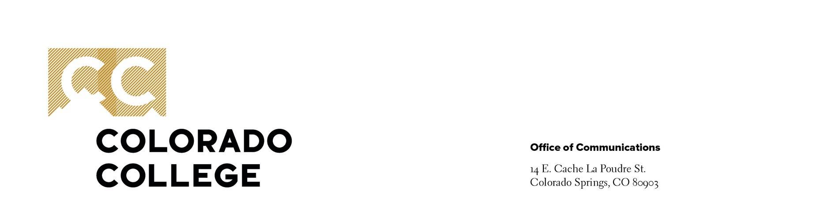

FOR IMMEDIATE RELEASE

Contact: Alexa Gromko
719-360-8401
agromko@coloradocollege.edu

Colorado College Receives $2.5 Million Gift to Endow Innovative Career Catalyst Program
Transformational funding supports immersive learning experiences that bridge classroom and career

COLORADO SPRINGS, Colo. — August 12, 2025 — Colorado College has received a $2.5 million gift to endow its groundbreaking Career Catalyst Program, which provides students with immersive, faculty-led learning experiences that connect the liberal arts to real-world professional challenges.
Launched in 2024, the Career Catalyst Program leverages the flexibility of CC’s distinctive Block Plan to create high-impact, experiential learning opportunities both on and off campus. The transformational investment from the MacLean family ensures that the Career Catalyst Program will remain a core component of the CC experience for generations to come.
“Colorado College has been part of our family for over a century now — from my grandmother who graduated in 1925, to me in the 80s, and now through my sons, who graduated in 2021 and 2023,” said Liz MacLean Larned ’83. “With this gift, we’re excited to help today’s students prepare for the future — not just by building skills, but by discovering how their passions can shape meaningful careers. The Career Catalyst program does just that, and we’re honored to help it grow.”
The 2024 pilot of the off-campus program included a two-week immersive course at Mattel’s global headquarters in Los Angeles, while on-campus blocks brought real-world problem solving into the classroom. Visiting faculty member Lora Louise Broady successfully piloted the model in the Economics and Business Department, spurring plans for program expansion to additional departments in the future.
The Career Catalyst Program is projected to impact more than 150 students each year, helping each of them identify, develop, and celebrate the unique talents they’ll use to launch their professional careers. In its first year, the program led to direct outcomes for students with one participant in the off-campus block securing a job after graduation and two students in the on-campus program earning internships from alumni executives involved.
“This extraordinary gift allows us to reimagine our learning environments in ways that reflect the complexity of the world our students will enter,” said President Manya Whitaker. “By investing in spaces that foster interdisciplinary thinking and real-world application, the MacLean family is helping us demonstrate how a liberal arts education translates into bold leadership and meaningful impact.”
The MacLean gift will support the development of additional Career Catalyst Blocks across a wide range of disciplines, each guided by intentional faculty mentorship and focused on building essential, transferable skills such as teamwork, critical thinking, and creative problem solving. In addition to expanding the program’s reach, the endowed fund will reduce — or, for some blocks, eliminate — financial barriers, ensuring all students have access regardless of background or aid status. The gift will also support faculty as they design and deliver rigorous, career-connected curricula and foster new forms of cross-campus collaboration.
The next off-campus Career Catalyst Block, scheduled for fall 2025, will take students inside National Geographic to explore the intersection of storytelling, science, and global impact.

About Colorado College
Colorado College is a nationally prominent, four-year liberal arts college that was founded in Colorado Springs in 1874. In 1970 the college created the Block Plan, in which its approximately 2,300 undergraduate students take one class at a time in intensive 3½-week segments. A Master of Arts in teaching degree also is offered. The college’s vision is to ignite students’ passion and potential to create a more just world. For more information, visit www.coloradocollege.edu.

###

